Pushing changes made to a work order down through the hierarchy

This script will allow for the current unique id sequence to be used to set the record key value rather then an autokey. It is written generically so that launch points may be written for work order, PO, tickets, etc while leveraging the same script. When this is being used, it is suggested that the autokey be removed from the field in question. While this example uses the reported by field as its launch point, it is recommended that a field that is not accessible to the user with a default value (to do the triggering) be used. The script can further be expanded to process differently by site or based on the interactive flag, etc.

Scripting with Maximo References:
https://www.ibm.com/developerworks/community/blogs/a9ba1efe-b731-4317-9724-a181d6155e3a/entry/scripting_with_maximo6?lang=en
https://www.ibm.com/developerworks/community/forums/ajax/download/77777777-0000-0000-0000-000014772567/b8ec7d85-6a8d-4e25-
bb89-d729c3322406/attachment_14772567_Scripting_with_Maximo.pdf

System Configuration > Platform Configuration > Automation Scripts
Action > Create a Script with an Attribute Launch Point

Automation Script Tab
Script Source:
key=str(id)

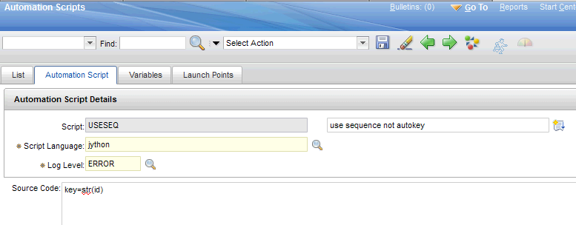

Variables Tab
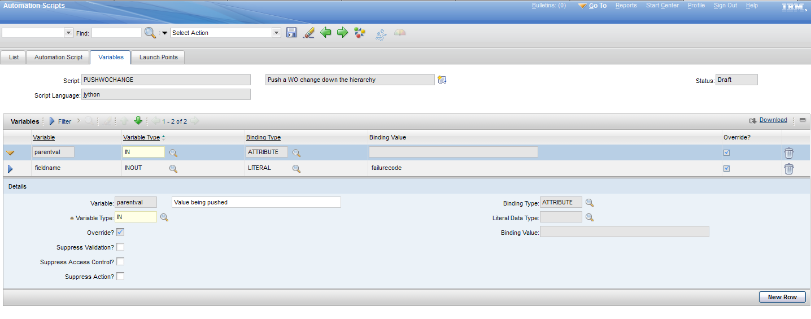

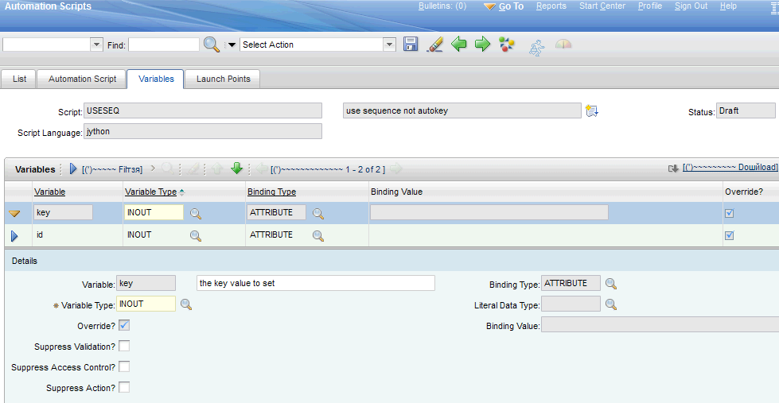

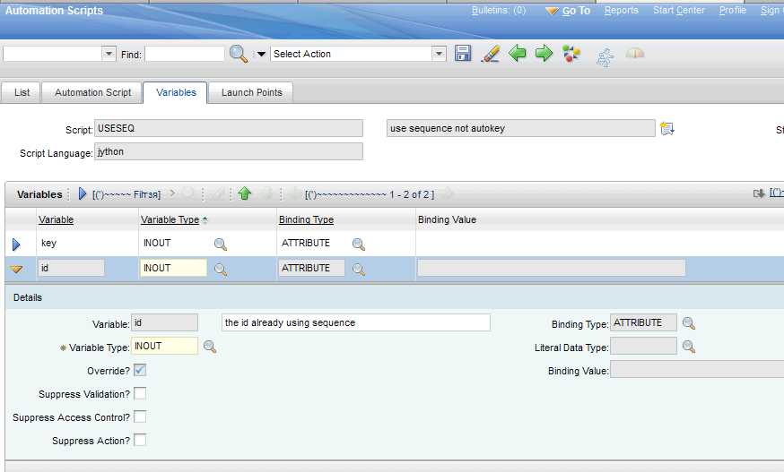

Launch Points Tab

